AI for Excel 101 resources

Flash fill: <https://stringfestanalytics.com/ai-powered-excel-how-to-get-the-most-of-flash-fill/>

**What is Flash Fill?**

Flash Fill is an AI-powered feature that automatically predicts patterns in data and fills in adjacent cells accordingly, streamlining data formatting and manipulation tasks for users.

**How to use it**

There are a few ways to activate Flash Fill, all of them fairly straightforward.

**Just start typing!**

Probably the easiest way to use Flash Fill: just start typing! In fact, you might have already used it without even knowing. For instance, consider the following example where we aim to extract first names from a range of cells:



While this could have been accomplished with a variety of ways in Excel, including [Text to Columns](https://support.microsoft.com/en-us/office/split-text-into-different-columns-with-the-convert-text-to-columns-wizard-30b14928-5550-41f5-97ca-7a3e9c363ed7), there’s something so satisfying and well, artificially intelligent about Flash Fill, right?

**Through the home ribbon**

Here’s another example: extracting the year from a range of dates. If typing doesn’t trigger Flash Fill, access it from the Data tab of the ribbon and choose Flash Fill:



**Ctrl + E**

You can also activate Flash Fill with the keyboard shortcut Ctrl + E, in this case to extract the last four digits of a credit card number:



**What if Flash Fill doesn’t work?**

If you encounter issues triggering Flash Fill, ensure that it is turned on. To do this, navigate to File on the ribbon, then go to Options > Advanced > Editing Options, and check the Automatically Flash Fill box.

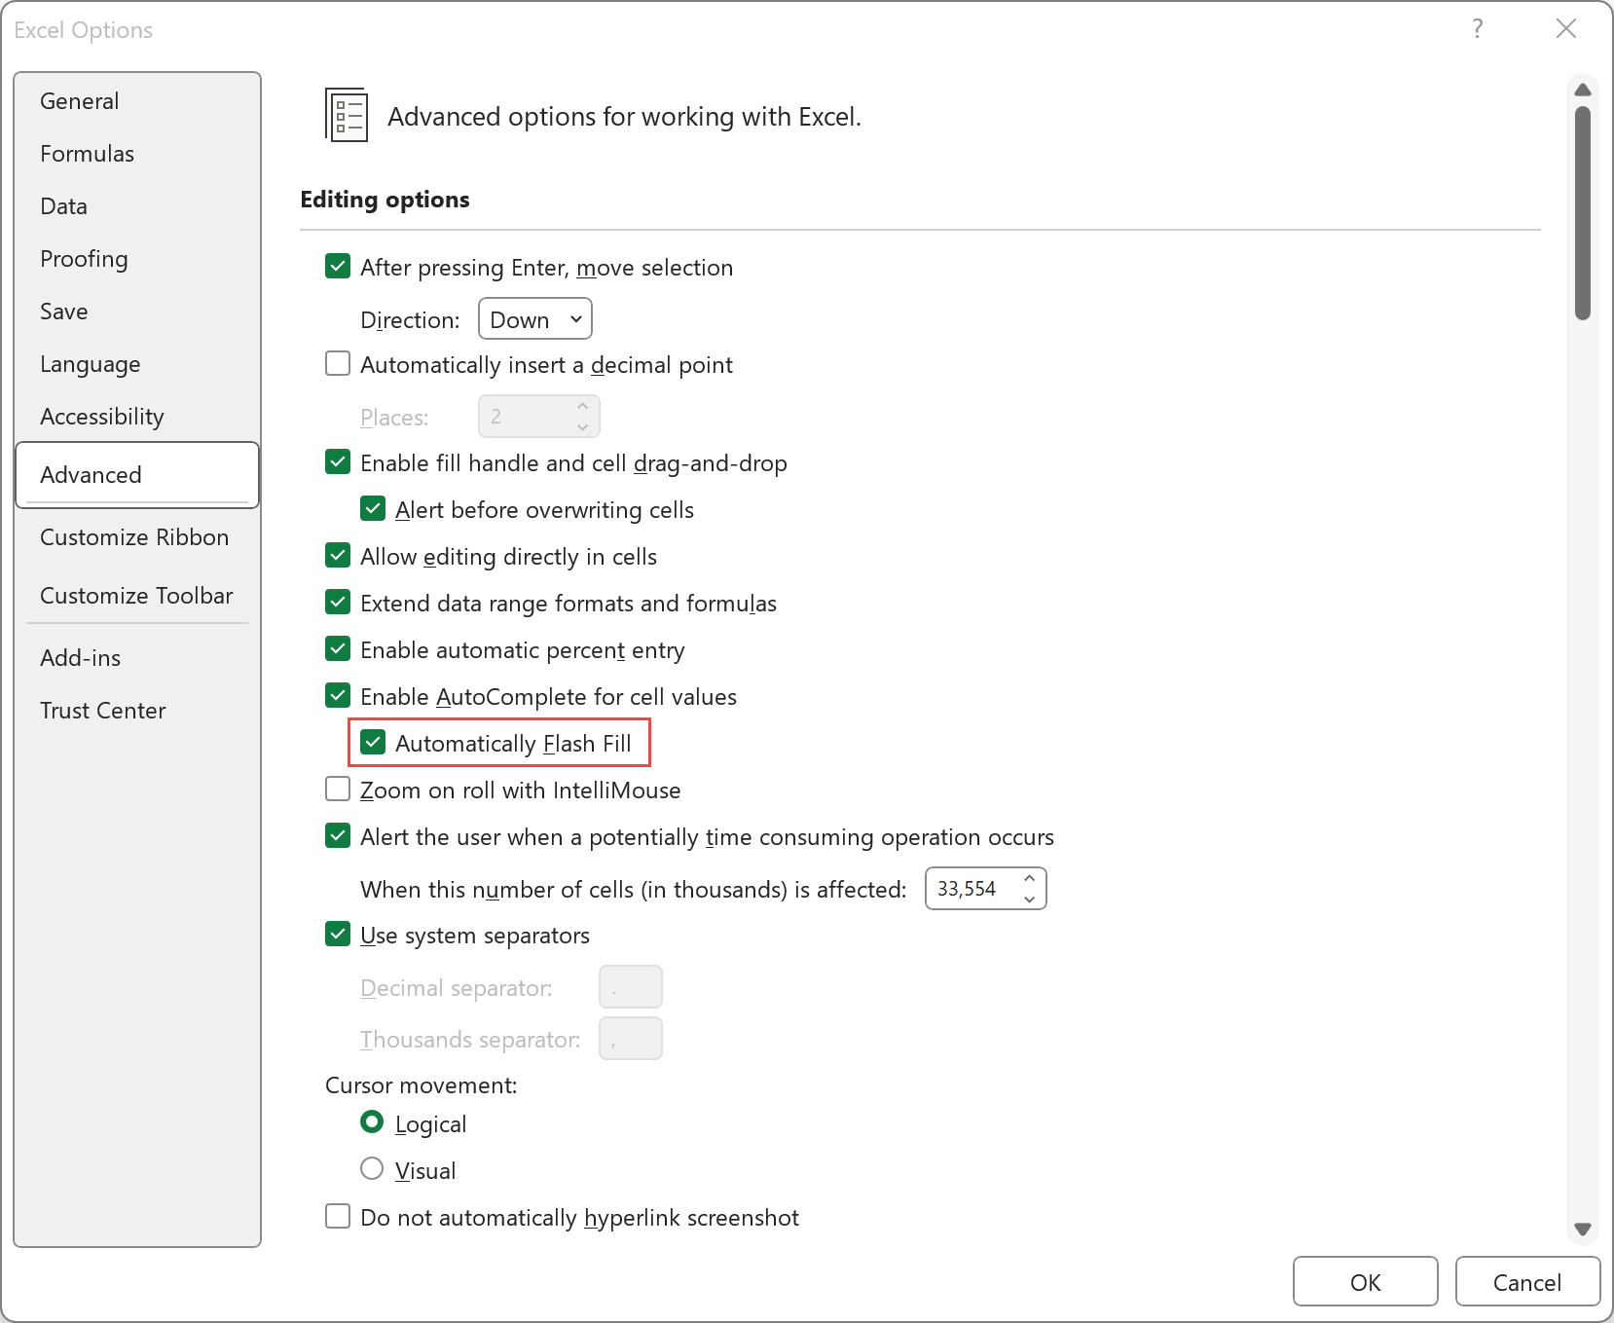

**Limitations of Flash Fill**

True to its name, Flash Fill offers a rapid solution for identifying patterns in your data. However, it only operates in cells immediately adjacent to the source data cells. Furthermore, the results of Flash Fill are not dynamic. If you modify or add to the source data, Flash Fill will not automatically adjust to accommodate the changes:



This is why foregoing Flash Fill for more robust methods like formulas or Power Query may be a better option for ongoing data preparation tasks. Fortunately, a [Formula by Example](https://techcommunity.microsoft.com/t5/excel-blog/more-on-formula-by-example/ba-p/3728914) feature is rolling out to Excel that combines the auditability or formulas with Flash Fill’s ease of use.

For now, we’ll celebrate our big, quick data cleaning win with Flash Fill:

[Download the solutions here](https://github.com/summerofgeorge/blog-files/raw/master/excel-flash-fill-demo-solutions.xlsx)

**How is Flash Fill considered AI?**

Flash Fill is considered AI because it employs advanced algorithms, pattern recognition, natural language processing, and predictive input to automate data transformations. As users start typing in a new column, the AI engine analyzes adjacent data to identify patterns. It also adapts based on additional user input, continuously improving accuracy. Its ability to automate complex tasks without requiring manual formulas or scripts makes it a textbook AI feature.

Fun fact: Flash Fill started from a serendipitous meeting of a Microsoft researcher and a businesswoman on a flight. To learn more about how a scientific research project became a tool now used regularly by millions, [check out this post](https://www.microsoft.com/en-us/research/blog/flash-fill-gives-excel-smart-charge/).

What questions do you have about Flash Fill in Excel specifically or AI for Excel more generally? Let me know in the comments.

Import data from picture: <https://stringfestanalytics.com/how-to-import-data-from-a-picture-in-excel/>

**Importing the image into Excel**

For this demo, we’ve got a handful of customer reviews that exist only as printed copies. We’d like to import them into Excel with the ultimate hope to conduct [sentiment analysis](https://www.mrexcel.com/excel-tips/excel-2020-perform-sentiment-analysis-in-excel/) on them. Let’s give it a try:

[Download the exercise files here](https://github.com/stringfestdata/excel-read-from-image/archive/refs/heads/main.zip)

Open a new Excel workbook and select Data > Get & Transform Data > From Picture > Picture from File:

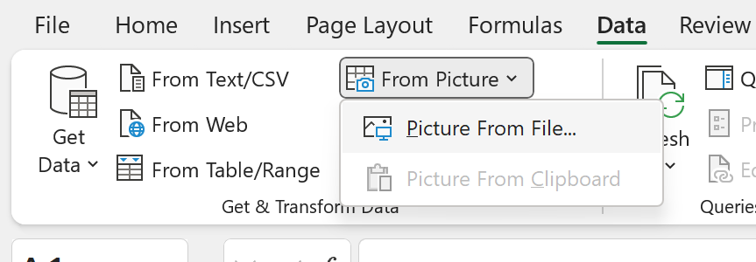

From here, you can navigate to and select the scanned_reviews.png exercise file. Import the file and you should see a Data from Picture menu to the right of your workbook:

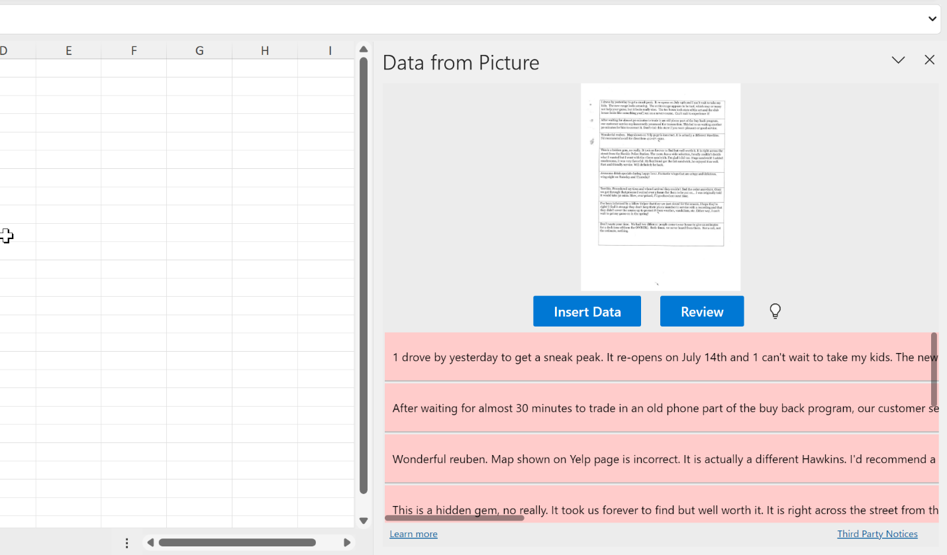

**Reviewing possible errors**

Just like magic, Excel was able to convert this into text… right? Well, OCR is not magic. It does make mistakes. And, thanks to other artificial intelligence (AI) features, Excel can even detect where these mistakes are likely located.

In this case, Excel has flagged all but one record as likely containing an error. You can click Review to scan and double-check each of them, then make any adjustments to the data. For example, the first entry starts with the letter 1 when it should be the pronoun I:

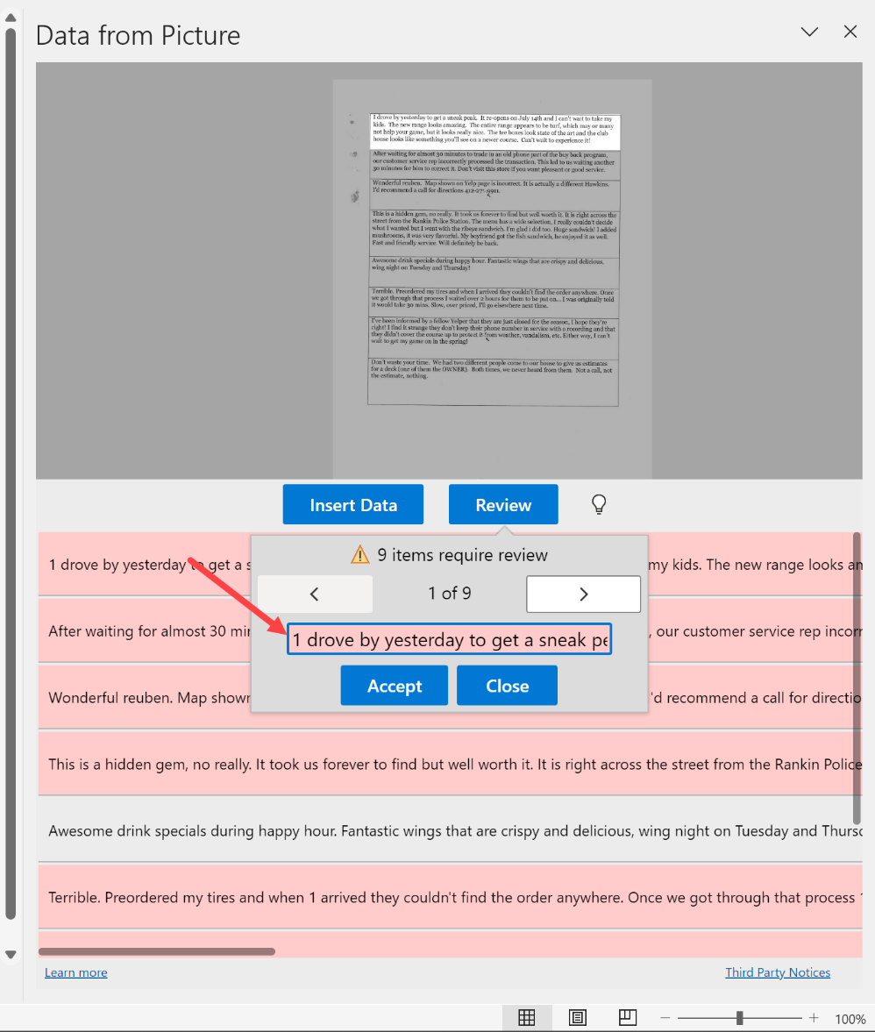

You can continue to search through and review any possible erroneous entries. Click “Insert Data” when you’re done to move the results to Excel.

**False positives and negatives**

Excel’s AI does a decent job predicting when text is likely to contain an error, but it’s not perfect. For example, it could detect an error in one entry when none exist — known as a *false positive*in statistics. On the flipside, it could approve an entry that actually *does*have errors — a false negative.

The balance between flagging potential false positives and false negatives is one of the biggest topics in statistics and machine learning. For now, we’ll trust Excel to get it right, but as you continue in your analytics journey there may be places where it’s best for you to decide yourself.

**Inserting and reviewing the data**

Excel isn’t the most natural place to store unstructured data like text, so you may encounter some issues with inserting the text.

For the sake of organization, it’s best to keep each review in its own discrete cell, so go ahead and manually make any adjustments. For example, it appears my text on rows 6 and 7 should really just be one review:

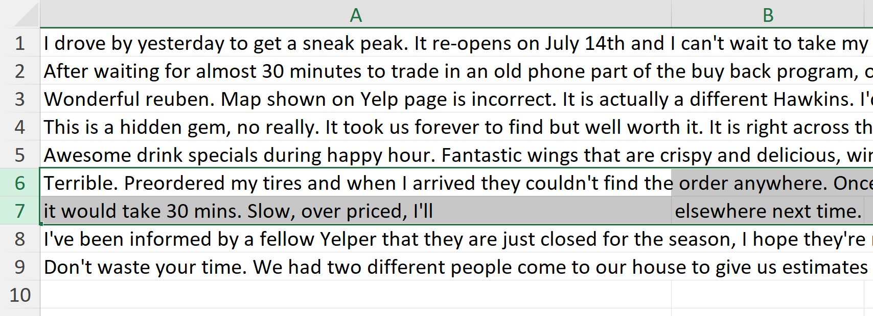

I’ve consolidated them into one in the solution file, available in [this post’s exercise files](https://github.com/stringfestdata/excel-read-from-image/archive/refs/heads/main.zip).

**Images in Excel: What next?**

OCR traditionally has been used to read text data — not exactly Excel’s bread-and-butter, although that may be changing as tools like [sentiment analysis](https://www.mrexcel.com/excel-tips/excel-2020-perform-sentiment-analysis-in-excel/) become available. However, a variety of number-driven applications do exist — perhaps, for example, you’ve got a financial statement you want to analyze but it only exist as a printed record, smartphone photo, or so forth. And while not a novel technology to Excel, having OCR right in Excel is as convenient as it gets.

I hope you can use this feature to save hours of busywork — but remember! AI isn’t perfect, and it’s very likely the OCR will produce false positives and false negatives. How to respond depends on the circumstances of your project. Think through the AI first, then use it and you’ll be in great shape to shine.

Have you used Excel’s OCR features, and for what purpose? How has the distinction between false positives and false negatives mattered in your work? Let me know in the comments.

Recommended PivotTable: <https://stringfestanalytics.com/ai-powered-excel-insert-a-pivottable-with-recommended-pivottable/>

**AI-Powered Excel: Insert a PivotTable with Recommended PivotTable**

posted on JULY 29, 2023 [(Edit)](https://stringfestanalytics.com/wp-admin/post.php?post=11523&action=edit)

Excel’s PivotTable has always been a powerful tool for data analysis, but with the introduction of the Recommended PivotTable feature, it has become even more accessible and intuitive to unearth valuable insights from your data. This post serves as a short introduction to this feature using the [mpg dataset](https://github.com/mwaskom/seaborn-data/blob/master/mpg.csv):

[Download the exercise file here](https://github.com/summerofgeorge/blog-files/raw/master/recommended-pivottable-demo-start.xlsx)

**Availability and how it works**

Recommended PivotTables leverage the same technology as Analyze Data in Excel, making them accessible in both the 365 versions of Excel and Excel for the web. For AI beginners, it’s advisable to start with this feature before delving into [Analyze Data](https://support.microsoft.com/en-us/office/analyze-data-in-excel-3223aab8-f543-4fda-85ed-76bb0295ffc4), as it provides additional guardrails to the process.

**How to insert a recommended PivotTable**

The experience will closely resemble the regular PivotTable process. Simply click on your dataset, then go to Insert > Recommended PivotTables. A menu will pop up to the right of your data, displaying various potentially interesting configurations for the PivotTable:



Keep in mind that, being AI-driven, the results might vary over time due to the probabilistic nature of the algorithm.

Of the presented options, I like the idea of viewing weight by mpg and cylinders. So I’m going to insert it into a new sheet:



This feature is quite impressive, but it’s not all-knowing. For instance, the PivotTable currently summarizes mpg by taking its sum, whereas an average would be more meaningful. However, you have the flexibility to address this by adjusting the value field settings in the PivotTable, just like with any other PivotTable.

In fact, you can continue iterating on this to explore various possibilities, such as breaking down cylinders by origin:

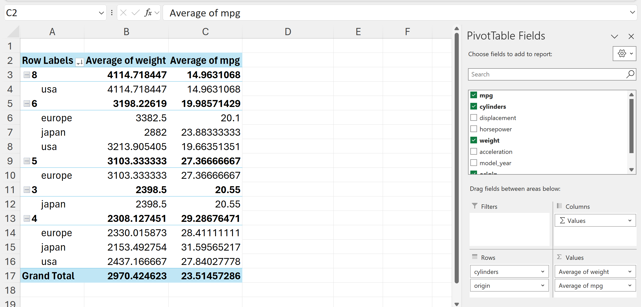

Recommended PivotTables are best viewed as starting points. While they can guide you in the right direction, they won’t handle everything.

**Pros and cons of Recommended PivotTables**

This feature is beneficial for users less familiar with PivotTables and are looking for a jump-start or those seeking quick analysis without delving deep into PivotTable creation. It’s also useful for those hesitant about more advanced AI involvement.

However, assuming the algorithm is always 100% correct is risky. For instance, the aggregation type for mpg in this PivotTable wasn’t optimal—it was summed, which didn’t make much sense. You may need to take a more interventionist approach when using AI. That’s where [Analyze Data](https://support.microsoft.com/en-us/office/analyze-data-in-excel-3223aab8-f543-4fda-85ed-76bb0295ffc4) comes in, enabling you to query the data more effectively using natural language.

For now, compare your results with the file below:

Recommended Charts: <https://stringfestanalytics.com/ai-powered-excel-how-to-get-the-most-of-recommended-charts/>

Data visualization is both an art and a science, and selecting the right chart can be overwhelming. My advice is to start by getting something on the page to break the logjam. You can always refine or completely change your chart later.

AI serves as a great collaborative, brainstorming assistant, and a prime example is Recommended Charts in Excel. This post demonstrates its capabilities and how to make the most of it using a straightforward example.

[Download the exercise file here](https://github.com/summerofgeorge/blog-files/raw/master/excel-recommended-charts-demo.xlsx)

**Insert the basic chart**

To get started, click anywhere inside the dataset you want to visualize and select Insert > Recommended Charts. I’m going to go ahead and click OK on the first one recommended to me.



Did you get different recommended charts in a different order from the previous menu? Welcome to the unpredictable world of AI! Since output is generated probabilistically, results can vary for different users. [In that sense, it’s random](https://machinelearningmastery.com/randomness-in-machine-learning/).

Excel’s recommended charts are generally a good starting point, but some suggestions may be more suitable than others. Let’s examine the chart types Excel recommended in this example.

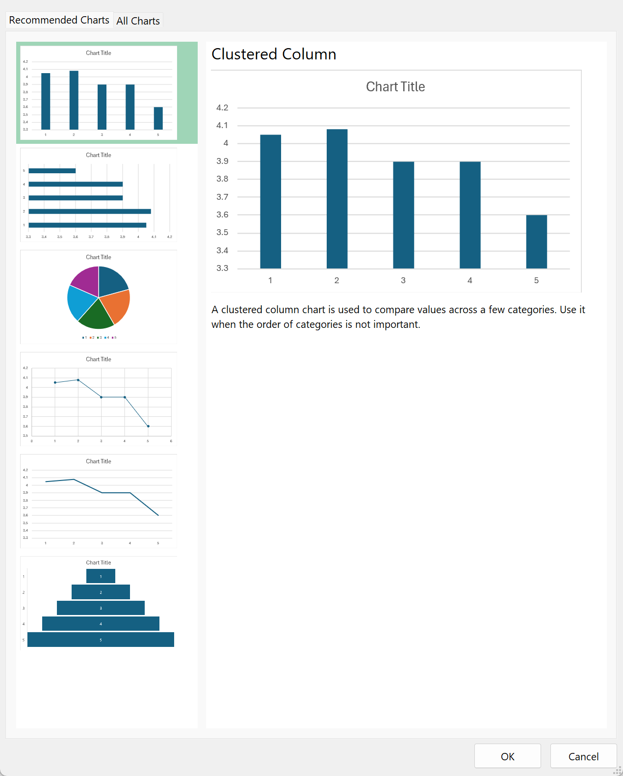

The next three charts (scatter, line, and funnel) all mistakenly treat the first column as a measure instead of a dimension. In the following section, we’ll explore how to correct this and make other necessary adjustments.

**Improving the results**

Recommended charts made a good choice with a bar chart. However, as with [other Excel data sources](https://stringfestanalytics.com/ai-powered-excel-how-to-prepare-your-data-for-best-results/), there are ways to optimize how well recommended charts perform.

**Clearly distinguish measures and dimensions**

Broadly speaking, we can separate variables between [measures and dimensions](https://www.metabase.com/learn/databases/dimensions-and-measures). Measures in data refer to numeric values that can be quantified, such as sales revenue or temperature, while dimensions represent non-numeric attributes like categories or labels, such as product names or customer names. Although dimensions are typically non-numeric, their occasional presence as numeric data can lead to confusion for algorithms when determining their roles in data visualization.

In our example, Excel might mistakenly interpret a variable labeled 1 through 5 as a sequence, making it appear suitable for a line chart. To avoid this confusion, use labels that clearly distinguish between measures and dimensions. In this case, using region names instead of numbers could be more useful:

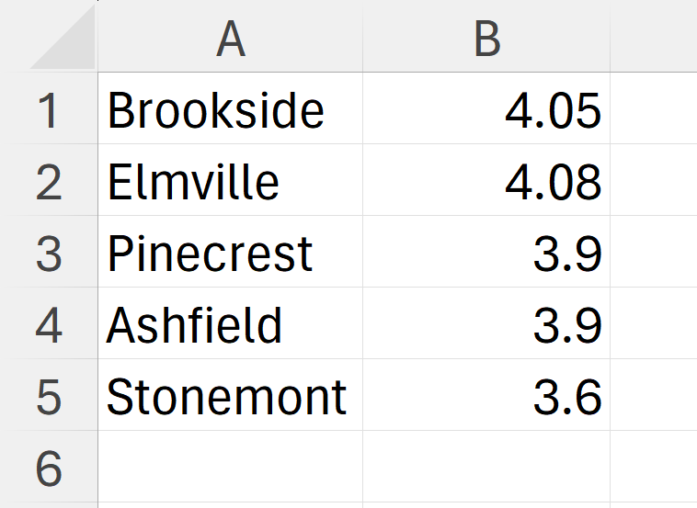

**Use labels**

Including column header labels in Recommended Charts helps Excel interpret the data accurately and ensures the resulting chart is appropriately labeled for better data understanding. Go ahead and add them to the data:

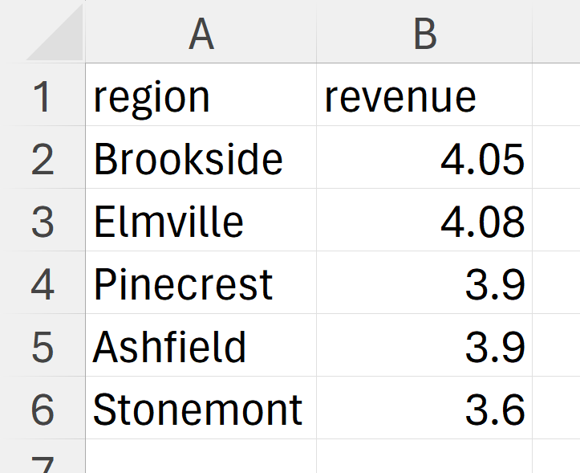

After making these changes, insert a new Recommended Chart, and you’ll notice that although some poor choices like a line chart have been removed, they are replaced by other inadequate options like a map:



Excel’s assumption that this data is geographical isn’t quite accurate, as these aren’t real places.

With AI assistance, we chose the bar chart as a safe option. There’s room to improve this plot by sorting and removing gridlines. AI can help you get started, but your human expertise takes the plot from good to great.

**How is this AI?**

Recommended Charts is an example of AI because it uses algorithms to analyze the data you select and suggests the most suitable chart type for effectively visualizing that data. By understanding the data’s nature and relationships, the AI identifies patterns and trends, recommending the chart that best communicates the insights in a meaningful way.

Compare your file with the solutions: